Literature Review

Rehabilitation Assistive Gloves (Project Idea 1):

**Article 1**:

In the article *A Novel Wearable Soft Glove for Hand Rehabilitation and Assistive Grasping*, Zhu et al. contribute to the evolving domain of soft robotics by addressing critical gaps in hand rehabilitation devices. Their work is firmly rooted in the context of improving rehabilitation tools for individuals with hand impairments, such as stroke victims, patients with spinal cord injuries, and those suffering from degenerative diseases like Parkinson’s. The authors recognize the limitations of conventional rigid exoskeletons and seek to extend the capabilities of soft robotic gloves by adding new functionalities, improving flexibility, and optimizing control systems.

**Context of Soft Robotic Gloves in Rehabilitation**

Hand rehabilitation is essential for patients who experience a loss of motor function due to injury or illness. Conventional rehabilitation techniques often require one-on-one therapy, which can be time-consuming, expensive, and inaccessible to many. To address these issues, the integration of robotics in rehabilitation has become a promising field, with a particular focus on exoskeletons and soft robotic gloves.

Traditional rigid exoskeletons, while capable of assisting in movement, often present several challenges: they are heavy, uncomfortable, expensive to produce, and can sometimes restrict the natural motion of the hand. As a result, soft robotics, with its lightweight and flexible structures, offers a more viable solution for wearable rehabilitation devices.

Soft robotic gloves are typically designed to mimic the natural movement of the human hand using soft materials and actuators, which provide the necessary movement with minimal discomfort. Earlier works in this field have explored various methods of achieving finger flexion and extension through pneumatic actuators, which inflate to create movement, or through tendon-based systems that simulate muscle contraction. However, one of the main limitations in previous designs was the lack of abduction/adduction movements for fingers (i.e., spreading and closing of the fingers), which is essential for more complex tasks like grasping larger or irregular objects.

**Key Innovations in This Study**

In their work, Zhu et al. build on previous efforts by addressing this limitation and designing a glove that not only supports the flexion and extension of each finger but also incorporates abduction and adduction for all five fingers, including the thumb. This extended range of motion is critical for enhancing rehabilitation outcomes, as it allows patients to perform more natural and varied hand movements during therapy.

**Structure Design and Fabrication of the Soft Glove**

The core innovation in this glove design lies in its use of soft pneumatic actuators combined with flexible rotating actuators, all mounted on a fabric glove. The soft actuators bend when pressurized, allowing the fingers to flex and extend, while the rotating actuators placed between the fingers enable the abduction and adduction motions. This dual-actuator system is designed to replicate the full range of hand movements in a way that rigid exoskeletons cannot.

The authors used a **silicone casting method** to manufacture these soft actuators, drawing on techniques such as the lost wax method. The material choice and fabrication technique are crucial in achieving the desired flexibility and durability. The actuators are made of soft elastomers that can withstand the repeated inflation and deflation cycles needed for rehabilitation. Unlike rigid devices that can feel uncomfortable or restrictive, the use of soft materials ensures that the glove can conform to different hand sizes and shapes, making it more adaptable to individual users.

This fabrication method also allows the actuators to be sewn onto a fabric glove, further enhancing the wearability of the device. This approach follows a trend seen in prior studies (e.g., Polygerinos et al., 2015; Yap et al., 2017), where soft materials were preferred for their ability to interact safely with the human body while minimizing the risk of injury.

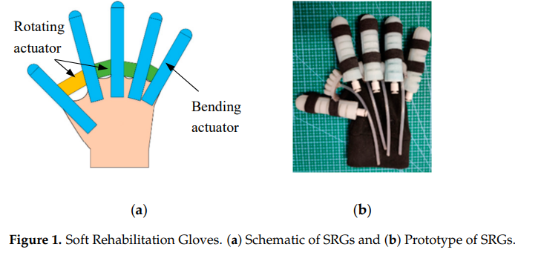

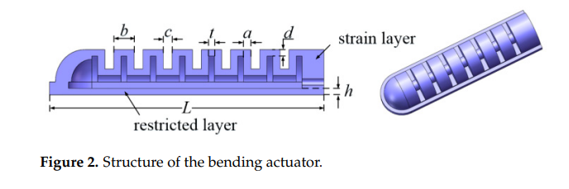

**The Novel Force/Position Hybrid Control System**

One of the most significant contributions of the article is the development of a **force/position hybrid PID control system**. In rehabilitation, it is essential that the glove not only assists the user in moving their fingers but does so in a way that adapts to their specific needs and limitations. Many earlier designs relied solely on position control, meaning that the device would assist in moving the fingers to a pre-programmed position. However, this method does not account for variations in how much force the user can apply, nor does it adapt to changes in the rehabilitation process over time.

In contrast, the **hybrid control system** developed by Zhu et al. allows for a more refined approach, where the glove can switch between controlling the position of the fingers and regulating the amount of force being applied. For instance, when the glove is used for grasping, the system can monitor the force applied by the fingers and adjust accordingly to prevent over-pressurization or excessive force that could harm the patient. The glove uses flexible strain and force sensors to provide real-time feedback on finger positions and the amount of force being exerted. This closed-loop control system ensures that the glove can respond dynamically to the user's needs, making it more effective in rehabilitation sessions.

The **hybrid PID controller** calculates the error between the desired and actual position or force and adjusts the pressure applied to the actuators accordingly. By switching between force and position control modes, the glove can assist in both gentle movements, such as when the user is regaining initial motion, and in more complex tasks, like precision grasping, where force control is critical. This adaptability is a significant improvement over earlier designs that lacked the flexibility to switch between different modes of control.

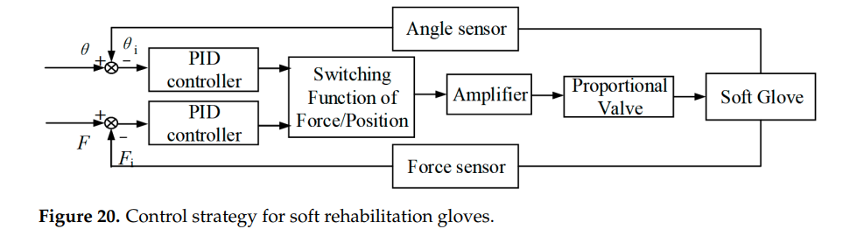

**Simulation and Experimental Validation**

To validate their design, Zhu et al. conducted both **finite element simulations** and **experimental tests** on the glove. The finite element method (FEM) was used to simulate how the soft actuators would deform under different pressure levels, allowing the authors to optimize the structure of the glove before manufacturing it. These simulations provided insights into how the actuators would behave when subjected to real-world conditions, helping to refine the design to ensure that it could deliver the necessary range of motion without failure.

In their experimental tests, the authors focused on evaluating the **mechanical performance** of the actuators in terms of bending angles, force output, and the ability to support both rehabilitation exercises and precise grasping. The bending actuators demonstrated a maximum bending angle of 130°, which is sufficient for most rehabilitation needs. The rotating actuators provided the necessary abduction/adduction movements, and the combined system showed the glove's potential to support complex hand motions. The experimental results closely matched the predictions made during the FEM simulations, validating the effectiveness of the glove's design.

The tests also demonstrated the effectiveness of the **hybrid control system**, showing that the glove could accurately control finger movements and switch between force and position modes. The glove's ability to dynamically adjust to different pressures and forces makes it a more flexible and adaptable tool for rehabilitation, offering improved performance over static position-based control systems.

**Broader Implications and Future Directions**

The glove presented by Zhu et al. offers a promising solution for hand rehabilitation, addressing many of the challenges faced by earlier designs. By incorporating both flexion/extension and abduction/adduction, and using an advanced control system, the glove represents a significant step forward in the development of soft robotic rehabilitation devices.

This work also opens the door for further research in several key areas:

* **Customization for individual patients**: Future research could focus on personalizing the glove for different hand sizes, injury types, or rehabilitation stages, ensuring optimal results for each user.
* **Advanced sensor integration**: Integrating more sophisticated sensors or combining the glove with machine learning algorithms could enhance its ability to adapt to user behavior over time, offering personalized rehabilitation programs based on real-time data.
* **Expansion to other body parts**: The success of this glove suggests that similar soft robotic devices could be developed for other parts of the body, such as the elbow, shoulder, or lower limbs, providing comprehensive rehabilitation solutions for patients with multiple motor impairments.

In conclusion, the article by Zhu et al. advances the field of soft robotics and rehabilitation by offering a more versatile, comfortable, and effective soft glove for hand rehabilitation. Through innovative design, precise control systems, and rigorous testing, the glove demonstrates significant potential for improving patient outcomes, making it a valuable contribution to the ongoing development of wearable rehabilitation devices.

**Article 2:**

The article "Design and Evaluation of a Bidirectional Soft Glove for Hand Rehabilitation-Assistance Tasks" focuses on developing a new hybrid actuator-based soft glove for stroke patients to enhance hand rehabilitation and support daily activities. Hand dysfunction, especially after strokes, limits the motor abilities of patients, impacting their quality of life and ability to live independently. While robotic devices have been introduced to aid in rehabilitation, conventional rigid exoskeletons have limitations, such as misalignment with natural joint movements, discomfort, and limited flexibility. Soft robotic solutions have emerged as a safer and more comfortable alternative, but most of them only assist with finger flexion (bending) and struggle to generate enough force for extension (straightening), an essential motion in rehabilitation.

**Key Components of the Study:**

1. **Hybrid Actuator Design**: The soft glove developed in this study integrates a flexion actuator made of silicone and an extension actuator composed of shape memory alloy (SMA) springs. The hybrid actuator design is crucial because it allows the glove to assist with both flexion and extension, which are necessary movements for hand rehabilitation. The flexion actuator is based on soft pneumatic actuation, where air pressure drives the bending motion, and the extension actuator employs SMA springs that revert to their original shape when heated, providing the necessary extension force.
   * Material and Structure Optimization: Finite element modeling (FEM) was used to optimize the critical design parameters, such as air cavity size and materials, to ensure both high bending angles and force output. The soft actuator material was carefully chosen to balance flexibility and strength, with Dragon Skin 30 providing the best results in terms of bending capacity and output force.

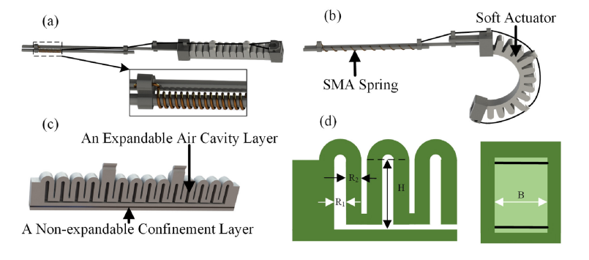

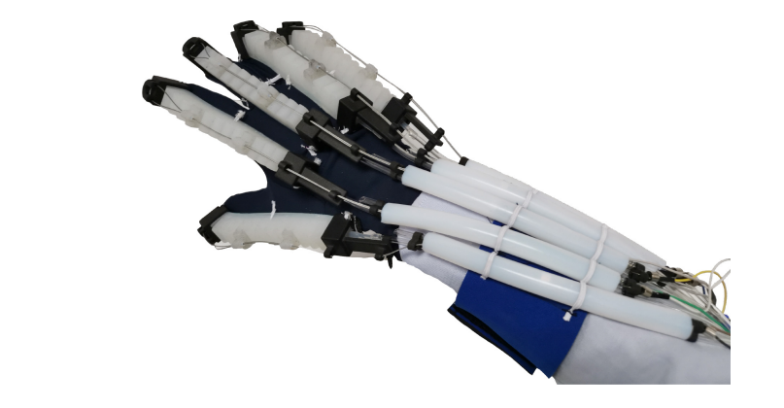

1. **Water-Cooling System**: One of the novel elements of the study is the inclusion of a water-cooling structure in the SMA spring actuator. This cooling system significantly reduces the response time of the SMA springs, which traditionally suffer from slow activation and deactivation times. By cooling the springs more efficiently, the glove's reaction time is shortened by 55.8%, enabling faster and more reliable assistance in hand movements. The faster response times make the glove more practical for real-time rehabilitation sessions.

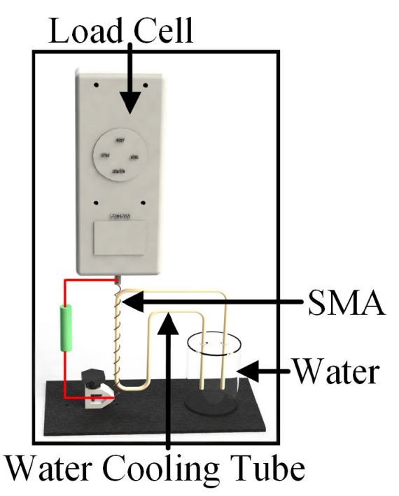

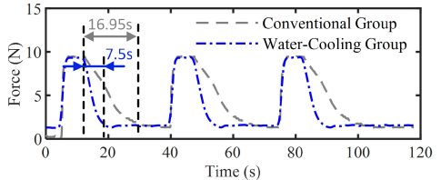

1. **Performance in Clinical Trials**: The glove was tested on eight stroke patients in clinical trials to evaluate its effectiveness in real-world rehabilitation tasks. The trials focused on key metrics such as the range of motion in finger joints (DIP, PIP, and MCP joints) and grip strength. The results were promising:
   * Improved Bending Angles: Without assistance, the patients' index fingers could only bend to an average of 6.8 degrees, but with the glove, this increased to 68.3 degrees for the PIP joint. Similarly, the MCP joint angle increased from 11.3 degrees to 68.1 degrees. These improvements reflect a significant enhancement in the range of motion, allowing patients to perform essential movements, like gripping and releasing objects.
   * Increased Grip Strength: The glove also helped increase the grip strength of the patients. For instance, the frictional force generated while holding a 50-mm cylinder increased from 8.4 N without assistance to 21.34 N with the glove.
2. **Control Systems and Modes**: The glove's control system integrates two operational modes:
   * Button Mode: This mode allows users to manually trigger specific movements using a mobile app. The interface enables users to perform predefined hand gestures such as gripping or holding objects, making the glove suitable for daily living activities (ADLs).
   * Mirror Rehabilitation Training: This mode combines mirror therapy, robotic rehabilitation, and virtual reality. A Leap Motion sensor captures the motion of the patient’s unaffected hand, and the glove mirrors these movements to the impaired hand, providing synchronized bilateral therapy. This method allows stroke patients to practice rehabilitative exercises in a more interactive and engaging manner.
3. **Comparison with Existing Solutions**: Prior designs of rehabilitation gloves focused primarily on finger flexion assistance, often using pneumatic or cable-driven mechanisms. However, many of these designs faced challenges such as limited extension capabilities, insufficient output force, and discomfort due to misalignment with the joints. The bidirectional soft glove presented in this article addresses these gaps by providing adequate force for both flexion and extension and improving user comfort and wearability through the soft materials used in the glove design.

**Conclusion**:

The bidirectional soft glove represents a significant advancement in hand rehabilitation technologies, providing patients with both comfort and daily living assistance. The combination of soft pneumatic actuators for flexion and SMA springs for extension delivers enhanced performance, increasing both the range of motion and grip strength of stroke patients. The integration of a water-cooling system, along with optimized control algorithms, ensures faster response times, making the glove more efficient for real-time rehabilitation tasks.

**References**:

Zhu, Y., Gong, W., Chu, K., Wang, X., Hu, Z., & Su, H. (2022). A novel wearable soft glove for hand rehabilitation and assistive grasping. *Sensors*, *22*(16), 6294. https://doi.org/10.3390/s22166294

Lai, J., Song, A., Shi, K., Ji, Q., Lu, Y., & Li, H. (2023). Design and evaluation of a bidirectional soft glove for Hand Rehabilitation-Assistance tasks. *IEEE Transactions on Medical Robotics and Bionics*, *5*(3), 730–740. https://doi.org/10.1109/tmrb.2023.3292414